1. Go To <http://107.167.191.87/moodle/login/index.php>
2. Web Page Shown Below Would Open.

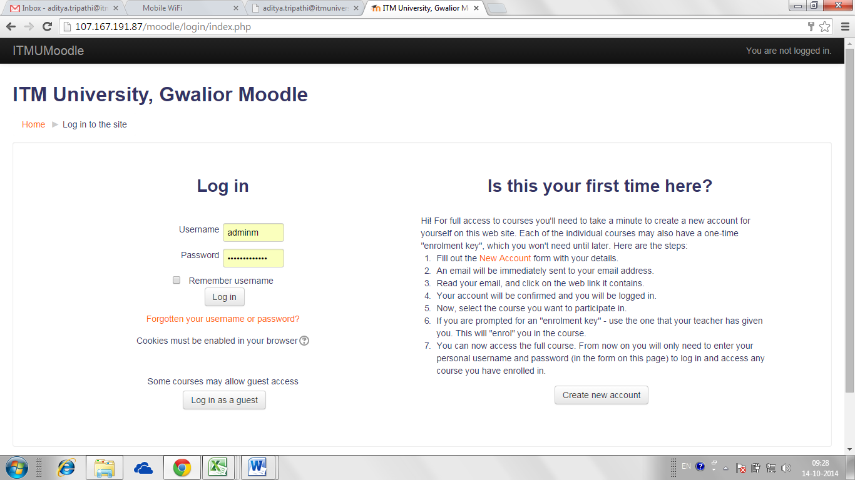

1. Click on the marked link “New Account” to open the Moodle registration form shown below.

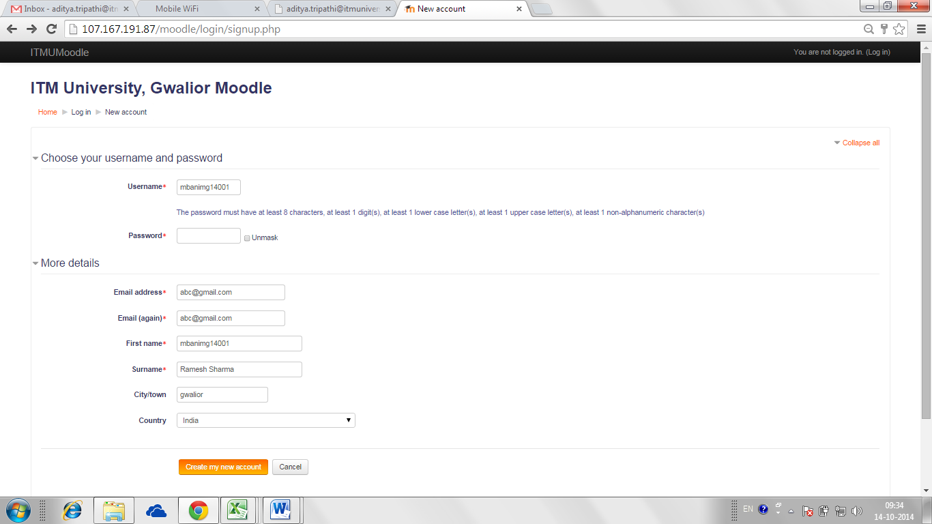

1. As shown in the screen shot above type your roll number in small letters for example mban1mg14001 in the field “Username”.
2. Give your password according to the rules i.e. the password must have at least 8 characters, at least 1 digit(s), at least 1 lower case letter(s), at least 1 upper case letter(s), at least 1 non-alphanumeric character(s).
3. Write your email address twice in the “Email address” and “Email (again)” fields as shown in the screenshot.
4. In the “First Name” field again type your roll number in Capital Letters for example MBAN1MG14001.
5. In the “Surname” field type your complete name for example Ramesh Sharma.
6. Type your city and country in the fields “City” and “Country” respectively.
7. At last click on “Create my new account” button to complete your registration process in Moodle.
8. At this stage is you may see the below shown webpage which may contain an error message saying “tried to send you an email but failed!”, you don’t need to worry about it as this will not stop you from creating your account on Moddle.

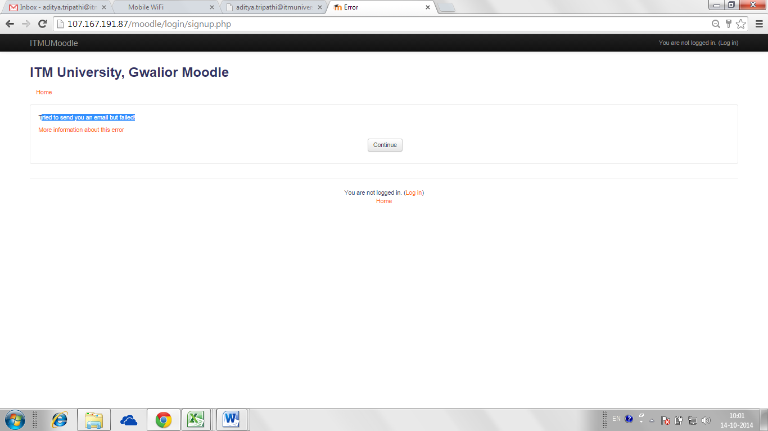

1. If you don’t see the above mentioned message then also it’s fine and your Moodle account has been created.
2. Within 24 hours of registration your account will be activated and you can start using Moodle.